A  
Project Report On  
THEORY & APPLICATIONS of SAMPLING THEOREM

*Signals and Systems (2141005)*

BACHELOR OF ENGINEERING  
in  
ELECTRONICS AND COMMUNICATION ENGINEERING

By  
Chaitanya Tejaswi 140080111013  
Drupad Pandya 140080111021

Under The Guidance of  
Prof. Robinson Paul  
Professor, ET Department.



ELECTRONICS & TELECOMMUNICATION ENGINEERING   
DEPARTMENT   
BVM ENGINEERING COLLEGE  
GUJARAT TECHNOLOGICAL UNIVERSITY  
VALLABH VIDYANAGAR-388120  
Academic Year- 2015-16

**CERTIFICATE**

This is to certify that the project report entitled **“THEORY & APPLICATIONS of SAMPLING THEOREM”,** submitted by **Chaitanya Tejaswi (140080111013) & Drupad Pandya (140080111021)** in the subject of the Signals and Systems for the Bachelor of Engineering in Electronics and Communication of BVM Engineering College, Vallabh Vidyanagar, Gujarat Technological University, is the record of work carried out by them under my supervision and guidance. In my opinion, the submitted work has reached a level required for being accepted for examination.

**Under The Guidance Of**Prof. Robinson Paul  
Professor  
ET Dept, BVM  
V V Nagar, Anand.

ELECTRONICS & TELECOMMUNICATION ENGINEERING   
DEPARTMENT   
BVM ENGINEERING COLLEGE  
GUJARAT TECHNOLOGICAL UNIVERSITY  
VALLABH VIDYANAGAR-388120  
Academic Year- 2015-16

**ACKNOWLEDGEMENTS**

*We would like to thank our all respective faculty members, who were always there for helping us with all our session.*

*We’d like to thank our classmates for suggesting ideas & sharing their opinion about our project.*

*At last we would like to thank our parents for their support and encouragement.*

**CONTENTS**

1. Introduction
2. Defining Sampling Theorem
3. Understanding Sampling Theorem
4. Understanding Sampling Theorem vis-à-vis Recovery
5. Recovery of Original Signal
6. MATLAB plots for Lowpass & Bandpass Filtered Sampling

**Introduction**

1. The “*Sampling Theorem”*, which is a relatively straightforward consequence of the “*Modulation Theorem”*, is elegant in its simplicity. It basically states that a bandlimited time function can be exactly reconstructed from equally spaced samples provided that the sampling rate is sufficiently high-specifically, that it is greater than twice the highest frequency present in the signal.
2. A similar result holds for both *continuous time* and *discrete time*.

One of the important consequences of the sampling theorem is that it provides a mechanism for exactly representing a bandlimited continuous-time signal by a sequence of samples, that is, by a discrete-time signal. The reconstruction procedure consists of processing the impulse train of samples by an ideal lowpass filter.

1. Central to the sampling theorem is the assumption that the sampling frequency is greater than twice the highest frequency in the signal. The reconstructing lowpass filter will always generate a reconstruction consistent with this constraint, even if the constraint was purposely or inadvertently violated in the sampling process. Said another way, the reconstruction process will always generate a signal that is bandlimited to less than half the sampling frequency and that matches the given set of samples. If the original signal met these constraints, the reconstructed signal will be identical to the original signal.
2. On the other hand, if the conditions of the sampling theorem are violated, then frequencies in the original signal above half the sampling frequency become reflected down to frequencies less than half the sampling frequency.

This distortion is commonly referred to as “*aliasing”,* a name suggestive of the fact that higher frequencies (above half the sampling frequency) take on the alias of lower frequencies.

1. The concept of aliasing is perhaps best understood in the context of simple sinusoidal signals. Given samples of a sinusoidal signal, many continuous time sinusoids can be threaded through the samples.

For example, if the samples were all of equal height, they could correspond to samples of a sinusoid of zero frequency or in fact a sinusoid at any frequency that is an integer multiple of the sampling frequency. From the samples alone there is clearly no way of determining which of the continuous sinusoids was sampled. The reconstruction filter, however, makes the assumption that the samples also correspond to a frequency less than half the sampling frequency; so for this particular example, the reconstructed output will be a constant. If, in fact, the original signal was a sinusoid at the sampling frequency, then through the sampling and reconstruction process we would say that a sinusoid at a frequency equal to the sampling frequency is aliased down to zero frequency (DC).

1. Thus, as we demonstrate in this project, if we sample the output of a sinusoidal oscillator and then reconstruct with a lowpass filter, as the oscillator frequency increases from zero, the output of the lowpass filter will correspondingly increase. The output frequency will match the input frequency until the oscillator frequency reaches half the sampling frequency. As the oscillator frequency continues to increase, the output of the lowpass filter will begin to decrease in frequency.
2. It is important to understand that in sampling and reconstruction with an ideal lowpass filter, the reconstructed output will not be equal to the original input in the presence of aliasing, but samples of the reconstructed output will always match the samples of the original signal.

**Defining Sampling Theorem**

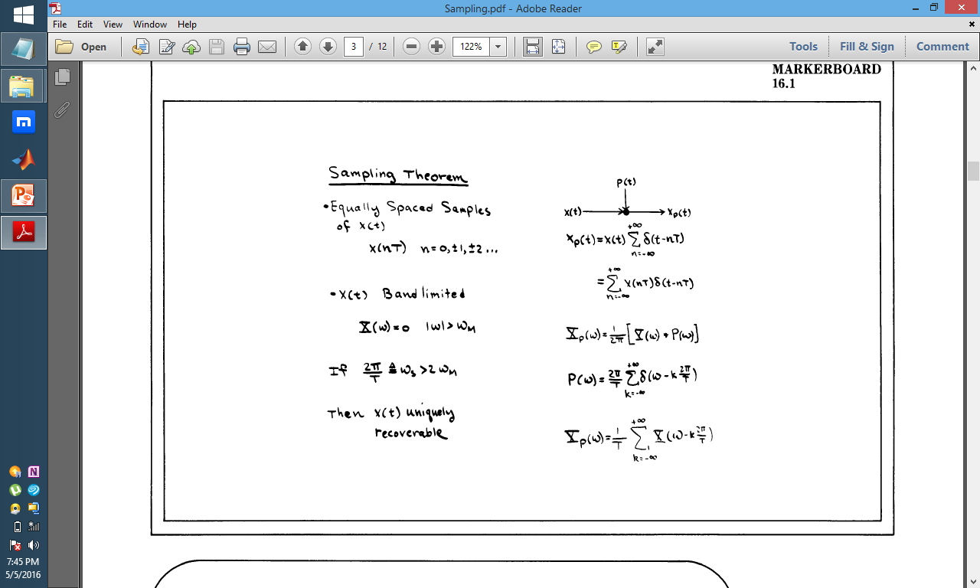

*“ For a CT signal , if we have equally spaced samples and the signal is bandlimited, then, if the sampling frequency is greater than twice the maximum band frequency , we can uniquely recover the signal using its samples. ”*

**Understanding Sampling Theorem**



**Observation**

*“ Fourier Transform of the sampled signal is a sum of frequency shifted replications of the Fourier Transform of the original signal.”*

**Conclusion**

*“ If a CT signal is sampled with the modulation train, the resulting spectrum is the original spectrum added to itself, shifted by integral multiples of the sampling frequency, . ”*

**Understanding Sampling Theorem vis-à-vis Recovery**

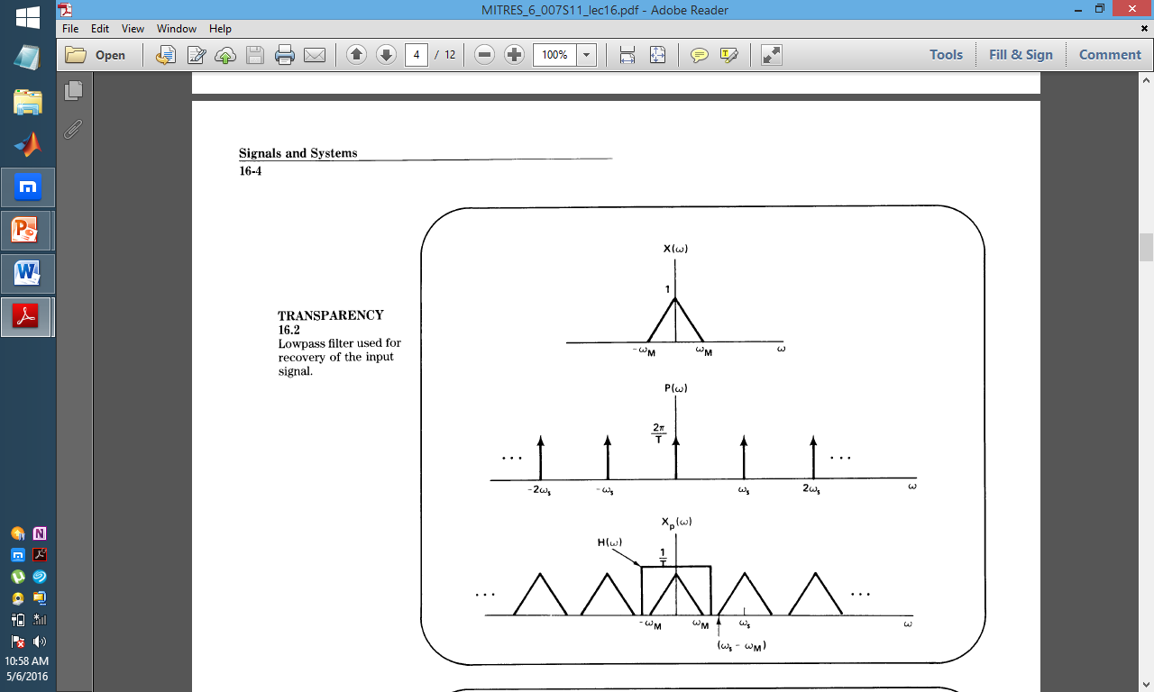

1. If we have an original signal with a spectrum as indicated in the first figure -- where it's band-limited with the highest frequency -- and if the time function is sampled so that in the frequency domain we convolve this spectrum with the spectrum shown below, which is the spectrum of the impulse train, the convolution of these two is then the Fourier transform or spectrum of the sample time function.
2. Recall that, to recover the original time function from this -- as long as these individual triangles don't overlap -- to recover it just simply involves passing the impulse train through a low-pass filter, in effect extracting just one of these replications of the original spectrum.

**Recovery of Original Signal**

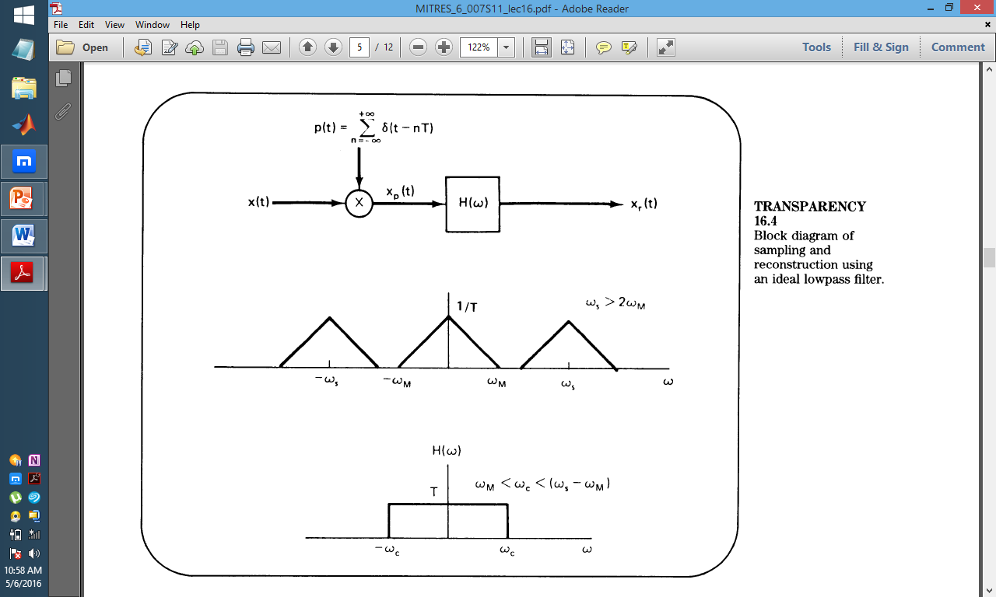

1. The overall system then for doing the sampling and then the reconstruction of the original signal from the samples, consists of multiplying the original time function by an impulse train. And that gives us then the sampled signal. The Fourier transform I show here of the original signal and after modulation with the impulse train, the resulting spectrum that we have is that replicated around integer multiples of the sampling frequency. And then finally, to recover the original signal or to generate a reconstructed signal, we then multiply this in the frequency domain by the frequency response of an ideal low-pass filter. And what that accomplishes for us then is recovering the original signal.
2. In doing the reconstruction-- what we've assumed-- is that in replicating these individual versions of the original signal, those replications don't overlap and so by passing this through a low-pass filter in fact, we can recover the original signal. Well, what that requires is that this frequency,, be less than this frequency. And this frequency is . So, what we require is that the frequency . Or equivalently, what we require is that the sampling frequency be greater than twice the highest frequency in the original signal.
3. Now, if in fact that condition is violated, then we end up with a very important effect referred to as ***aliasing***. 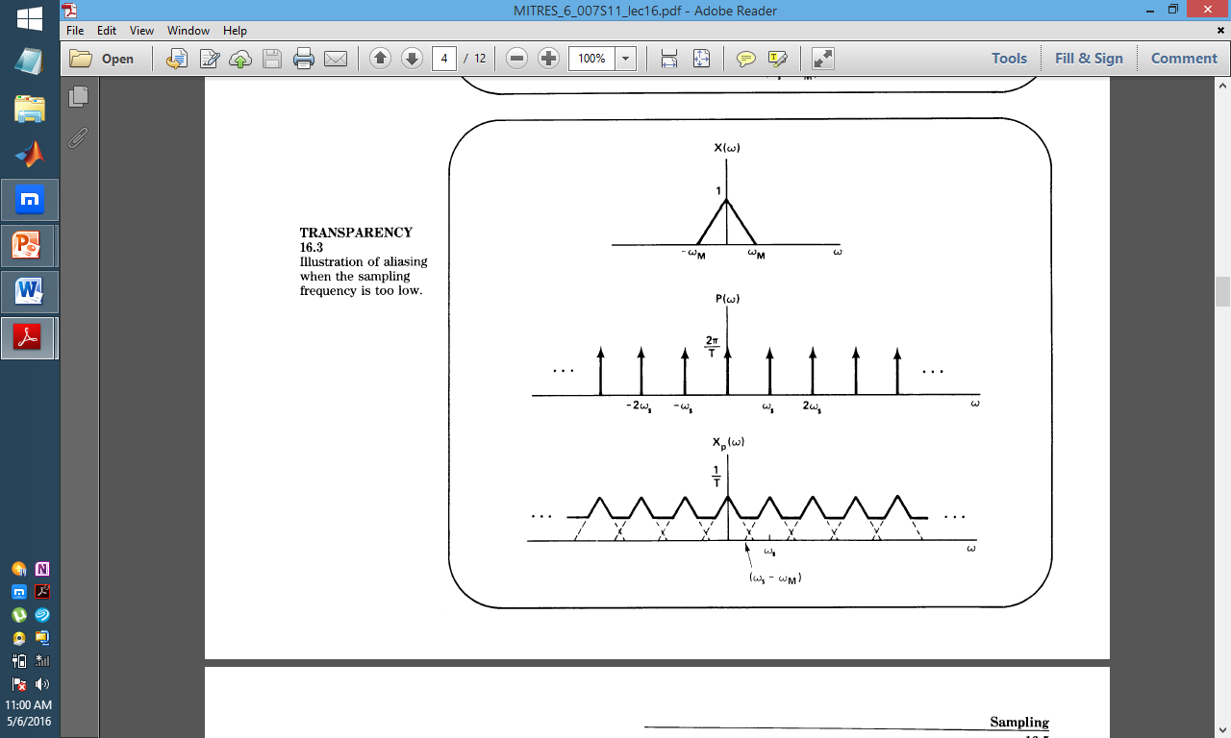
4. What happens here then is that in effect, higher frequencies get folded down into lower frequencies. What would come out of the low-pass filter is the reflection of some higher frequencies into lower frequencies.
5. And in order to both understand that term better and to understand in fact the effect better, it's useful to examine this a little more closely for the specific example of a sinusoidal signal.

**Effective Recovery of Original Signal**

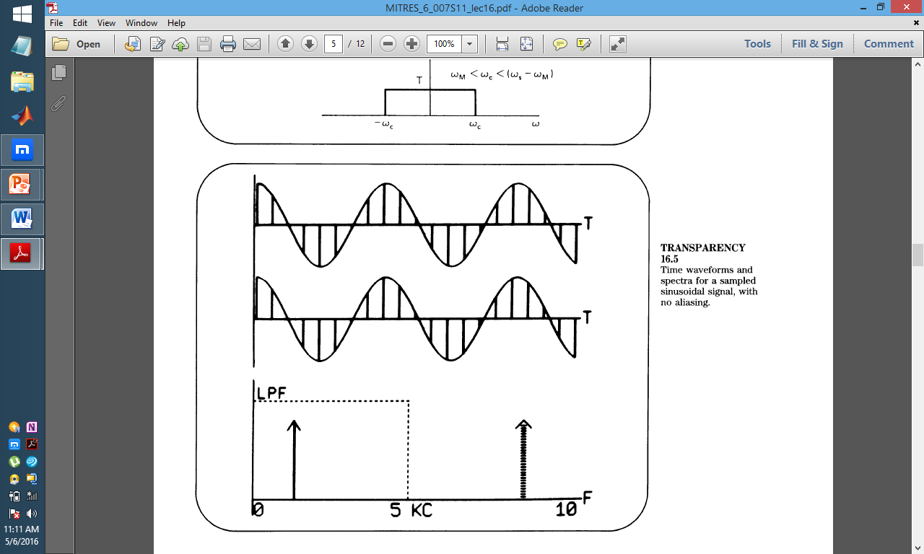

**Aliased Recovery of Original Signal**

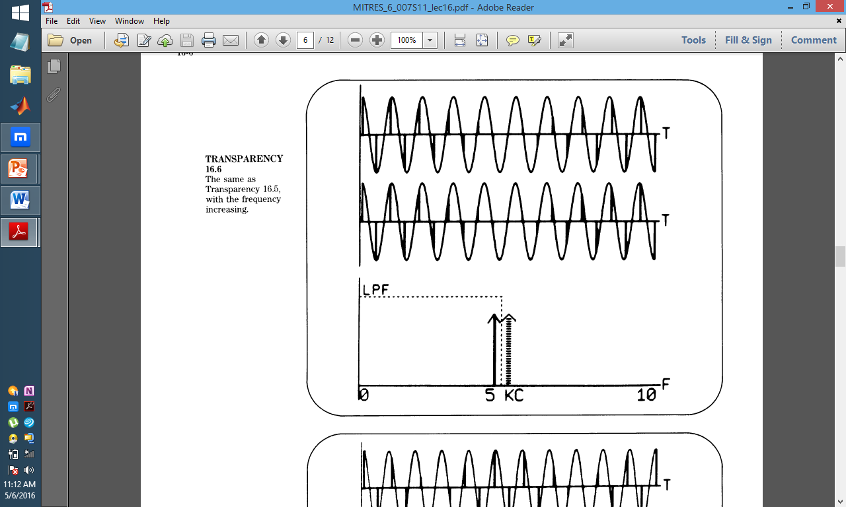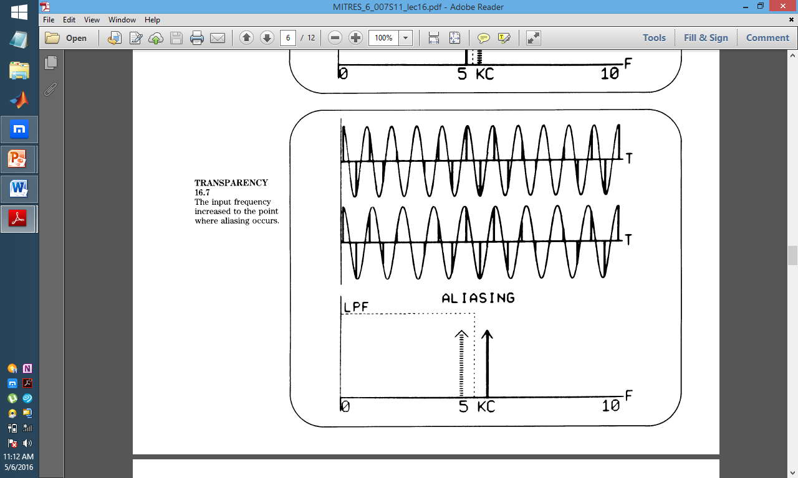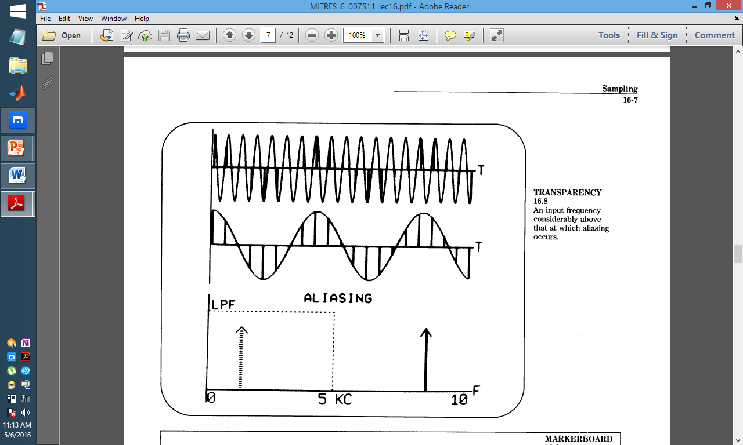

**MATLAB plots for Sampling**

% ===========================================================================

% MATLAB code to demonstrate sampling theorem

% ===========================================================================

clc; clear all; close all;

%% Specifications

Fc = 1; Fs1 = 100*Fc; Fs2 = 1.2*Fc; Fs3 = 2*Fc; Fs4 = 10*Fc;

t1 = 0:1/Fs1:10; t2 = 0:1/Fs2:10; t3 = 0:1/Fs3:10; t4 = 0:1/Fs4:10; % 10Sec

%% Signals

s1 = cos(2*pi*Fc*t1); % Original signal sampled at very high rate (100*Fc)

s2 = cos(2*pi*Fc*t2); % Original signal sampled at SR < 2*Fc (SR = Fc)

s3 = cos(2*pi*Fc*t3); % Original signal sampled at SR = 2*Fc

s4 = cos(2*pi*Fc*t4); % Original signal sampled at SR > 2*Fc (SR = 10*Fc)

%% Plot desired Signals

%% plot(X1,Y1,LineSpec,...,Xn,Yn,LineSpec) plots lines defined by the Xn,Yn,LineSpec triplets, where LineSpec specifies the line type, marker symbol, and color.

subplot(411); plot(t1,s1); title('For SR=100*Fc');

subplot(412); plot(t1,s1,'r',t2,s2,'b*-'); title('For SR < 2*Fc');

subplot(413); plot(t1,s1,'r',t3,s3,'b*-'); title('For SR = 2*Fc');

subplot(414); plot(t1,s1,'r',t4,s4,'b*-'); title('For SR > 2*Fc');

% ===========================================================================

**OUTPUT**

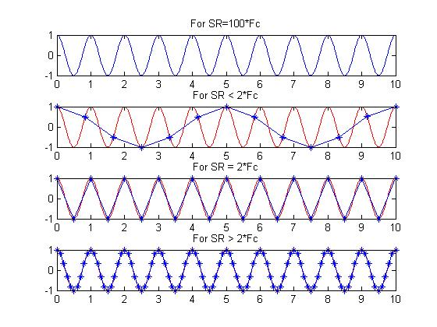

**MATLAB plots for Lowpass & Bandpass Filtered Sampling**

To better understand the frequency domain of sampling theory a collection of MATLAB m-files was created for plotting the frequency spectrum following ideal sampling. The tools decribed in this note are useful in analyzing the spectra following ideal sampling of real lowpass and bandpass signals.

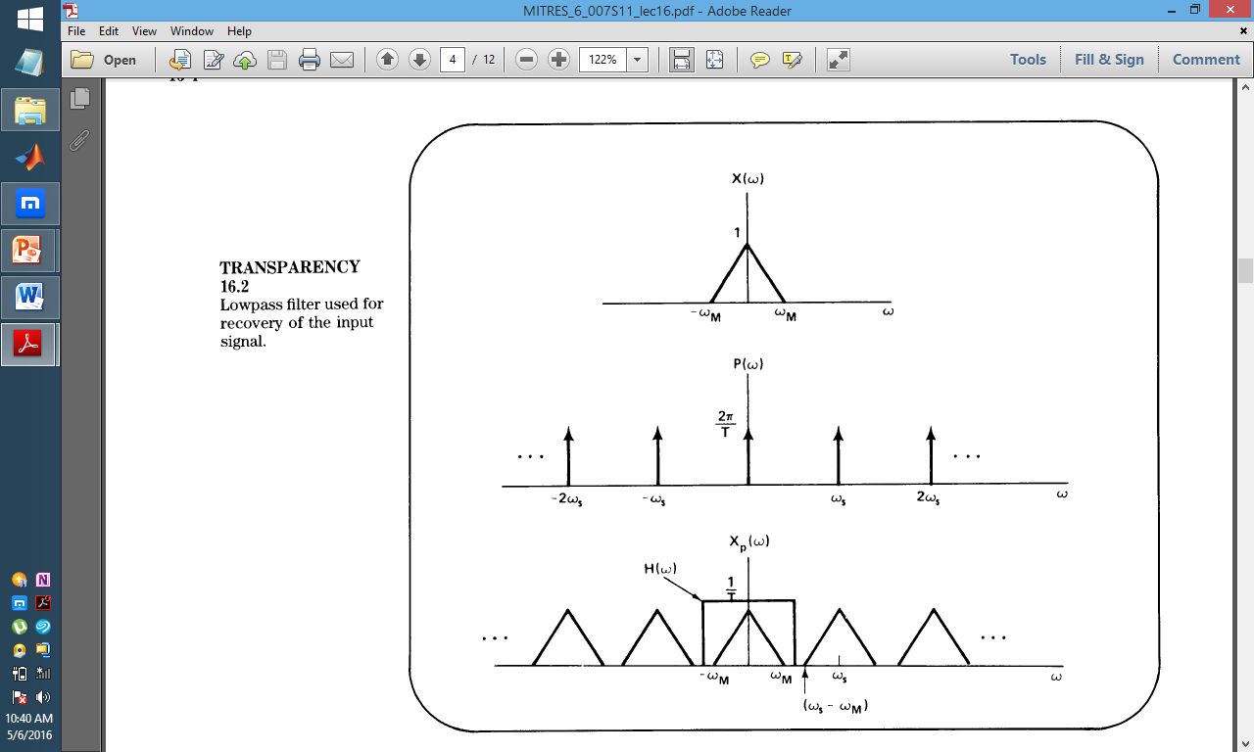

Using pre-defined MATLAB functions for lowpass ***“lp_tri( )”*** and bandpass filters (***“lp_tri( )” and “bp_tri( )”)*** for a signal with above triangular frequency plot, we design two equivalent functions, the MATLAB code for which are defined in the pages that follow.

**function lp_samp(fb,fs,fmax,N)**

* fb = spectrum lowpass bandwidth in Hz
* fs = sampling frequency in Hz
* fmax = plot over [-fmax,fmax]
* N = number of translates, N positive and N negative

***This function automatically creates a MATLAB plot using a predefined spectral shape taken from the function lp_tri( )***

**function bp_samp(fl,fh,fs,fmax,N,shape)**

* fl = spectrum lower frequency in Hz
* fh = spectrum upper frequency in Hz
* fs = sampling frequency in Hz
* fmax = plot over [-fmax,fmax]
* N = number of translates, N positive and N negative
* shape = basic spectral shape: 0-default upslope tri, 1-downslope tri

***This function automatically creates a MATLAB plot using a predefined spectral shape taken from the function bp_tri( )***

**m-File lp_samp(fb,fs,fmax,N)**

function lp_samp(fb,fs,fmax,N)

%**********************************************

% Lowpass Sampling Theorem Plotting Function

%**********************************************

% fb = spectrum lowpass bandwidth in Hz

% fs = sampling frequency in Hz

% fmax = plot over [-fmax,fmax]

% N = number of translates, N positive and N negative

**%This function automatically creates a MATLAB plot using a predefined %spectral shape taken from the function lp_tri( ).**

**% define the plot interval**

f = -fmax:fmax/200:fmax;

% plot the lowpass spectrum in black

plot(f,lp_tri(f,fb),'k');

**% overlay positive and negative frequency translates**

hold

for n = 1:N

plot(f,lp_tri(f-n*fs,fb),':r');

plot(f,lp_tri(f+n*fs,fb),':g');

end

hold

title(`Lowpass Sampling Theorem for a Real Signal: Blk = orig, dotted = translates')

ylabel(`Spectrum Magnitude')

xlabel(`Frequency in Hz')

**%function x = lp_tri(f, fb):**

function x = lp_tri(f, fb)

x = zeros(size(f));

for k=1:length(f)

if abs(f(k)) <= fb

x(k) = 1 - abs(f(k))/fb;

end;

end

**m-File bp_samp(fl,fh,fs,fmax,N,shape)**

function bp_samp(fl,fh,fs,fmax,N,shape)

%function bp_samp(fl,fh,fs,fmax,N,shape)

%***********************************************

% Bandpass Sampling Theorem Plotting Function %***********************************************

% fl = spectrum lower frequency in Hz

% fh = spectrum upper frequency in Hz

% fs = sampling frequency in Hz

% fmax = plot over [-fmax,fmax]

% N = number of translates, N positive and N negative

% shape = basic spectral shape: 0-default upslope tri, 1-downslope tri

**%This function automatically creates a MATLAB plot using a predefined**

**% spectral shape taken from the function bp_tri( ).**

**% use default shape for only 5 input arguments**

if nargin == 5

shape = 0;

end

% define the plot interval

f = -fmax:fmax/200:fmax;

**% plot the bandpass spectrum**

plot(f,bp_tri(f,fl,fh,shape),'k');

**% overlay positive and negative frequency translates**

hold

for n = 1:N

plot(f,bp_tri(f-n*fs,fl,fh,shape),':r');

plot(f,bp_tri(f+n*fs,fl,fh,shape),':g');

end

hold

title('Bandpass Sampling Theorem for a Real Signal: Blk = orig, dotted = translates')

ylabel('Spectrum Magnitude')

xlabel('Frequency in Hz')

**% x = bp_tri(f, fl, fh, shape):**

function x = bp_tri(f, fl, fh, shape)

x = zeros(size(f));

if shape == 1

for k=1:length(f)

if abs(f(k)) <= fh

if abs(f(k)) >= fl

x(k) = (fh- abs(f(k)))/(fh-fl);

end;

end;

end

else

for k=1:length(f)

if abs(f(k)) <= fh

if abs(f(k)) >= fl

x(k) = (abs(f(k))-fl)/(fh-fl);

end;

end;

end

end

**BIBLIOGRAPHY**

*We would like to mention certain sources from which we borrowed heavily in the making of this project.*

**BOOK**

*Chapter 16, Sampling (Signals & Systems – Alan Oppenheim, Alan Willsky, Hamid S. Nawab)*

**RESOURCES**

*Lecture 16, RE .6-007, 1987 (Signals & Systems – Alan V. Oppenheim)*